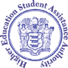

CHRIS CHRISTIE
Governor

KIM GUADAGNO
Lt. Governor
State of New Jersey
HIGHER EDUCATION STUDENT ASSISTANCE AUTHORITY

GABRIELLE CHARETTE, ESQ.
Executive Director

Dear Student,

Urgent Message to 2015-2016 Tuition Aid Grant (TAG) Recipients:

File your FAFSA today to apply for renewal of your TAG for the upcoming
2016-2017 academic year.

TAG renewal students must file a FAFSA no later than June 1, 2016. Processing can take several weeks. Don't delay!
File your FAFSA now at www.fafsa.gov.

On the Confirmation Page (shown below), select Start your state application to respond to a few additional questions required to determine your eligibility for New Jersey State grant and scholarship assistance, such as the Tuition Aid Grant and NJ STARS programs.

To check the status of your application, log on to www.fafsa.gov or call the Federal Student
Aid Information Center at 1-800-433-3243.

FOR THE 2017-2018 ACADEMIC YEAR YOU CAN FILE YOUR FASFA AS EARLY AS OCTOBER 1, 2016!!

Questions?
HESAA is here to assist you.
Customer Care Line: 1-609-584-4480
Monday through Thursday, 8 a.m. to 8 p.m. and Friday 8 a.m. to 5 p.m. You can also visit us on the web at www.njgrants.org.

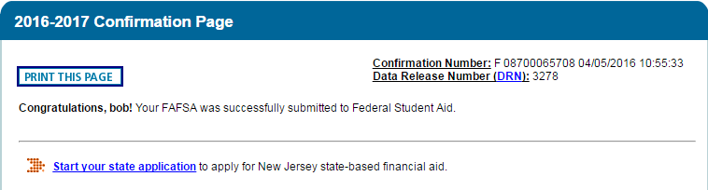

**This is an automatically generated email, please do not respond.
Copyright © HESAA 2016. All Rights Reserved.

